**Overview** **3**

Mission Statement and Objectives 4

ERD 5

Data Dictionary 6

Relational Schema 14

##### 

# Overview

*Classroom Connect* is a social media platform whereby students from all over the world can meet and share their scholarly experiences. The purpose of the platform is to help students gain insights on the next stages of their academic careers by connecting them with other students and alumni who have completed the programs they are interested in. As a forum where users can share firsthand experiences, *Classroom Connect* will allow students to research viable paths for their education and facilitate their preparations for their next academic endeavours.

Users begin by setting up an account, which only takes a name and email address. From there, they create their personal profiles. Profiles can include information such as academic experiences (previous and current), career interests, skills, awards, publications, completed courses and certificates, standardised tests, work experiences, and hobbies. Having completed their profile, users are granted full access to the platform and can begin interacting with other users. Interactions include adding other users to their network, posting updates, asking questions, upvoting or commenting on interesting posts, and searching for like-minded peers. Users can share content related to courses, program requirements, career paths, and extracurricular opportunities.

**USE CASES**

1. The application will allow students at any stage of their academic journey to connect and interact with alumni and current students from their current and target schools. Providing a platform to raise questions, get them answered and grow their network
2. Students will be able to load their personal, work and course related experience to the application for the benefit of other students
3. Students will be able to add posts, comment on posts, send personal messages and upvote the most helpful posts
4. Students will be able to view the profiles of alumni who got into their target schools and also look at the standardised test requirements for each of the programs
5. Students will be able to view alumni outcomes filtered by the program or the university. This will allow students to get a better view of their career progression before deciding on a school/program
6. Students will be able to search users based on their specific interests and/or awards to seek very specific and tailored guidance

## Mission Statement and Objectives

To bridge the gap between students around the world, facilitate their academic journey, empower them to make the best decision for their careers, and build the future they desire.

-Develop a platform to enable past, present, and future students to connect and share their post-secondary experiences, enriching one another with helpful information.

-Establish a bond between users like high school students, undergraduate, and graduate students.

-Provide clarification with respect to university admission requirements, international requirements, and transfer credits.

-Share information about anticipated course materials, pre-requisites, and classroom workload.

-Offer career assistance to internships, future job opportunities and expected work environment.

-Provide clarification in regards to the list of activities to get involved in, school logistics, and academic atmosphere.

### ERD

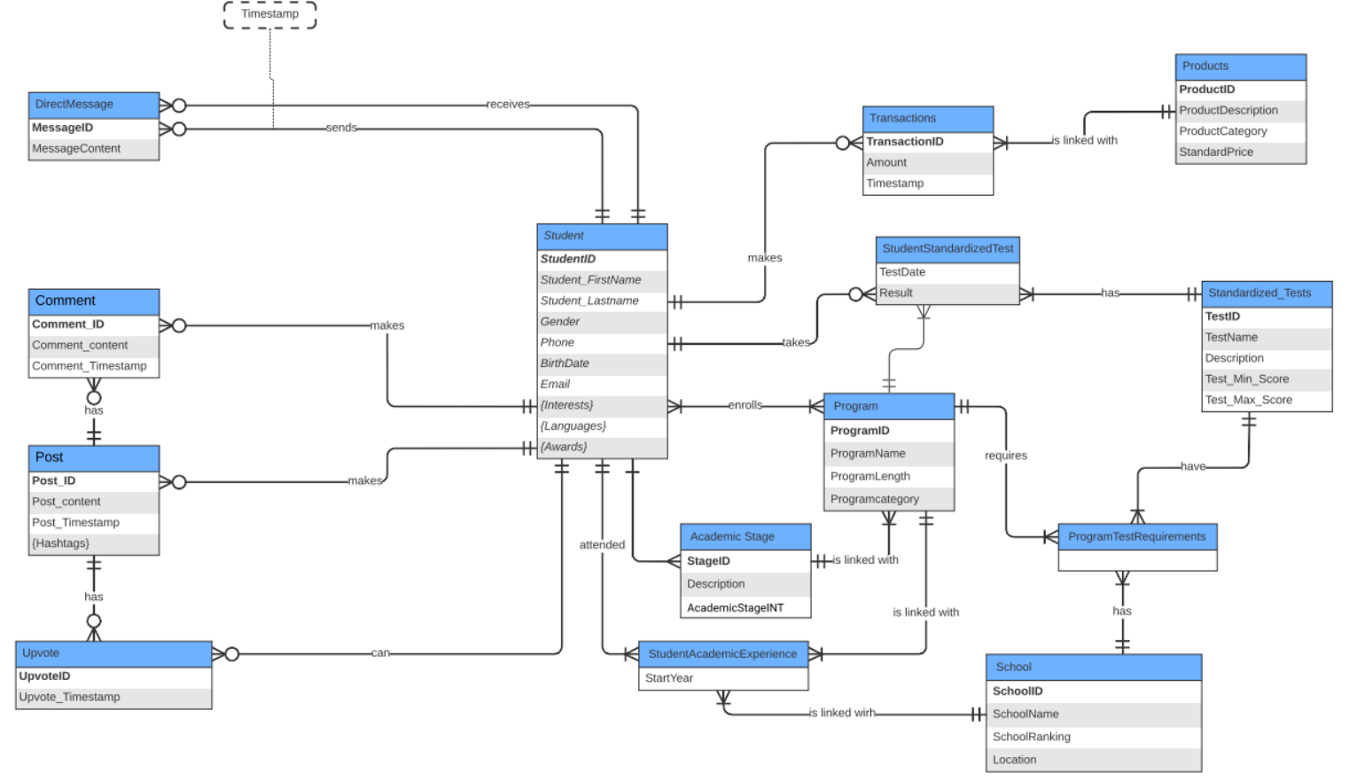

#### Data Dictionary

**Description of Entities**

|  |  |  |  |
| --- | --- | --- | --- |
| **Entity Name** | **Description** | **Aliases** | **Occurrence** |
| Student | Contains information about the student. | Student | One student can have many relationships with several other entities discussed below. |
| Academic Stage | Contains information about students' academic stage; stage ID and description. | AcademicStage | One academic stage must have at least one program and at least one student. |
| Student Academic Experience | Contains information about the start year along with student ID, school ID, and program ID | StudentAcademicExperience | One school must be linked with at least one student academic experience. One student must have at least one student academic experience. One program must be linked with one student academic experience. |
| School | Contains information about students' school ID, school name, school ranking, and school location. | School | One school must require at least one program test requirement, and must be linked with at least one student academic experience. |
| Program | Contains information about program ID, program name and program length. | Program | Each program must have a standardized test and require at least one program test requirement. At least one student must enrol in one program. |
| StudentStandardizedTest | Contains information about test date and result. | StudentStandardizedTests | One program can have the same standardized tests, one student can take many standardized tests(or none). One standardized test must have at least one student standardized test. |
| StandardizedTest | Contains information about testID, test name, description, minimum score required, and maximum score required. | StandardizedTest | One standardized test must have at least one student standardized test. One standardized test must have at least 1 program test requirement. |
| Transactions | Contains information about the amount of the transaction as well as the date. | Transactions | One student can make many transactions (or none). |
| Products | Contains information about the products linked with the transaction, the product description, category, and price. | Products | One product can be linked with at least 1 transaction. |
| Direct Message | Contains information about message content between students. | Direct_Message | One student can send many direct messages (or none). One student can receive many direct messages(or none) |
| Comment | Contains information about comment content between students as well as the comment date. | Comment | One student can have many comments (or none) and one post can have many comments (or none) |
| Post | Contains information post content and post date. | Post | One post can have many comments (or none) and one student can have many posts (or none). |
| Upvote | Contains information about the date of the upvote. | Upvote | One post can have many upvotes, and one student can perform many upvotes. |

**Description of Attributes**

|  |  |  |  |  |  |  |  |
| --- | --- | --- | --- | --- | --- | --- | --- |
| **Entity Name** | **Attributes** | **Description** | **Data Type** | **Nulls** | **Multi-valued** | **Derived** | **Default** |
| **Student** | *StudentID* | Unique ID of a student | Varchar | No | No | No | None |
|  | *Student_FirstName* | Student’s first name | Varchar | No | No | No | None |
|  | *Student_Lastname* | Student’s last name | Varchar | No | No | No | None |
|  | *Gender* | Gender of student | Varchar | Yes | No | No | None |
|  | *Phone* | Student’s phone number | Varchar | Yes | No | No | None |
|  | *BirthDate* | Student’s date of birth | Timestamp | No | No | No | None |
|  | *Email* | Student’s email address | Varchar | No | No | No | None |
|  | *Interests* | Student’s interests | Varchar | Yes | Yes | No | None |
|  | *Languages* | Student’s languages. | Varchar | No | Yes | No | None |
|  | *Awards* | Student’s awards. | Varchar | Yes | Yes | No | None |
| **School** | *SchoolID* | Student’s school unique ID. | Varchar | No | No | No | None |
|  | *SchoolName* | Student’s school name. | Varchar | No | No | No | None |
|  | *SchoolRanking* | The school’s ranking. | Int | No | No | No | None |
|  | *Location* | The school’s location | Varchar | No | No | No | None |
| **Program** | *ProgramID* | Student’s unique program ID | Varchar | No | No | No | None |
|  | *ProgramName* | Program name | Varchar | No | No | No | None |
|  | *ProgramLength* | The length of the program | Float | No | No | No | None |
|  | *ProgramCategory* | Program category like law, engineering | Varchar | No | No | No | None |
| **Academic Stage** | *StageID* | Student’s unique academic stage ID | Varchar | No | No | No | None |
|  | *Description* | Description of academic stage | Text | No | No | No | None |
|  | *AcademicStageINT* | Integer representation of academic stage | Int | No | No | No | None |
| **StudentAcademicExperience** | *StartYear* | The start year of the academic experience | Year | No | No | No | None |
| **StudentStandardizedTest** | *TestDate* | The test date of a standardized test | Timestamp | Yes | No | No | None |
|  | *Result* | The test result | Int | Yes | No | No | None |
| **Standardized Tests** | *TestID* | A standardized test’s unique ID | Varchar | No | No | No | None |
|  | *TestName* | The test’s name | Varchar | No | No | No | None |
|  | *Description* | The test’s description | Text | No | No | No | None |
|  | *Min_Score* | The minimum score for the test | Int | No | No | No | None |
|  | *Max_Score* | The maximum score for the test | Int | No | No | No | None |
| **Transactions** | *TransactionID* | A student’s unique transaction Id | Varchar | No | No | No | None |
|  | *Amount* | Amount spent on a certain transaction | Float | No | No | No | None |
|  | *Timestamp* | A transaction’s date | Timestamp | No | No | No | None |
| **Products** | *ProductID* | The unique product ID linked with the transaction ID | Varchar | No | No | No | None |
|  | *ProductDescription* | The description of the product | Varchar | No | No | No | None |
|  | *ProductCategory* | The category of the product | Varchar | No | No | No | None |
|  | *StandardPrice* | The product’s standard price | Float | No | No | No | None |
| **Direct Message** | *MessageID* | The message ID of a direct message sent by a student | Varchar | No | No | No | None |
|  | *MessageContent* | The content of the message | Text | No | No | No | None |
| **Comment** | *CommentID* | The comment ID of a comment made by a student | Varchar | No | No | No | None |
|  | *Comment_content* | The comment content | Text | No | No | No | None |
|  | *Comment_Tinestamp* | The comment date | Timestamp | No | No | No | None |
| **Post** | *PostID* | The post ID of a post made by a student | Varchar | No | No | No | None |
|  | *Post_content* | The post’s content | Text | No | No | No | None |
|  | *Post_Timestamp* | The post’s date | Timestamp | No | No | No | None |
|  | *Hashtags* | The post’s hashtags | Varchar | No | Yes | No | None |
| **Upvote** | *UpvoteID* | The ID of an upvote performed by a student | Varchar | No | No | No | None |
|  | *Upvote_Timestamp* | The date of the upvote | Timestamp | No | No | No | None |

##### Relational Schema

